**RESUME**

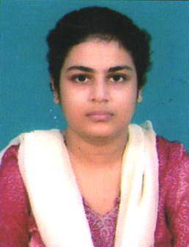**AMRITA BANERJEE**

**Chandernagore,**

**Hooghly**

**Ph. No. 8017788377**

**E-mail:** [**abamritabanerjee6@gmail.com**](mailto:abamritabanerjee6@gmail.com)**.**

**Career Objective:**

**A career in professional field, which provides opportunities for personal and professional development as well as to contribute to the organisation effectiveness in order to take the company to the top position where ever I work.**

**Professional Qualification:**

**MBA from Dr.P.C.Mahalanabish School of Management,Supreme Knowledge Foundation Group of Institutions,Under WBUT,AICTE approved,Mankundu.**

|  |  |  |  |  |
| --- | --- | --- | --- | --- |
| **Educational Qualification:** | | | | |
| **EXAMINATION** | **INSTITUTE** | **UNIVERSITY/**  **BOARD** | **YEAR OF PASSING** | **% of**  **Marks** |
| **MBA**  **(Finance-Marketing)** | **Dr.P.C.Mahalanabish School of Management,** | **WBUT** | **2011** | **71.6%** |
| **B.Sc**  **(Bio Science)** | **B.N.Mahavidyalaya** | **Burdwan** | **2001** | **53%** |
| **10+2 (Science)** | **UshanginiBalikaVidyalaya** | **W.B.C.H.S.E** | **1998** | **47.7%** |
| **Matriculation** | **St.Anthony’s High School** | **W.B.B.S.E.** | **1996** | **68%** |

**Extra curricular activity:**

**Got SANKAR’S INTERNATIONAL AWARD in drawing bySankarDayalSarma(Ex-President of India)& got 22pally AWARD in drawing in Kolkata.**

**On The Job Training:Two months training from Macmillan Publishers India Ltd.**

**Experience:Work as a receptionist in SMART COMPUTER centre( April 2003–May 2008).**

**Work as a sales Exe. in HDFC Bank ltd(July 2011-June 2012).**

**Work as a front office exe.&fl. Exe.atVASAN EYECARE HOSPITAL (December 2012-April 2015).**

**Working as a front cum back off executive at J. J. Automotive Ltd.(Bengal Hyundai) (Hyundai Motor India Ltd) (From July 2015) .**

**Personal Skills: Hardworking & Honest.**

**Personal Information:**

**Husband’s Name :Kinshuk Chatterjee.**

**Date of Birth :11th April 1979**

**Sex :Female**

**Nationality :Indian**

**Language Known :English,Hindi,Bengali**

**Marital Status :Married**

**Permanent Address:**

**C/O Kinshuk Chatterjee.**

**Chandernagore,**

**Hooghly.**

**Declaration :**

**I , Amrita Banerjee , hereby declare that all the above information furnished by me is true to the best of my knowledge and belief.**

**Date : Amrita Banerjee.**

**Place: Chandernagore (Signature)**